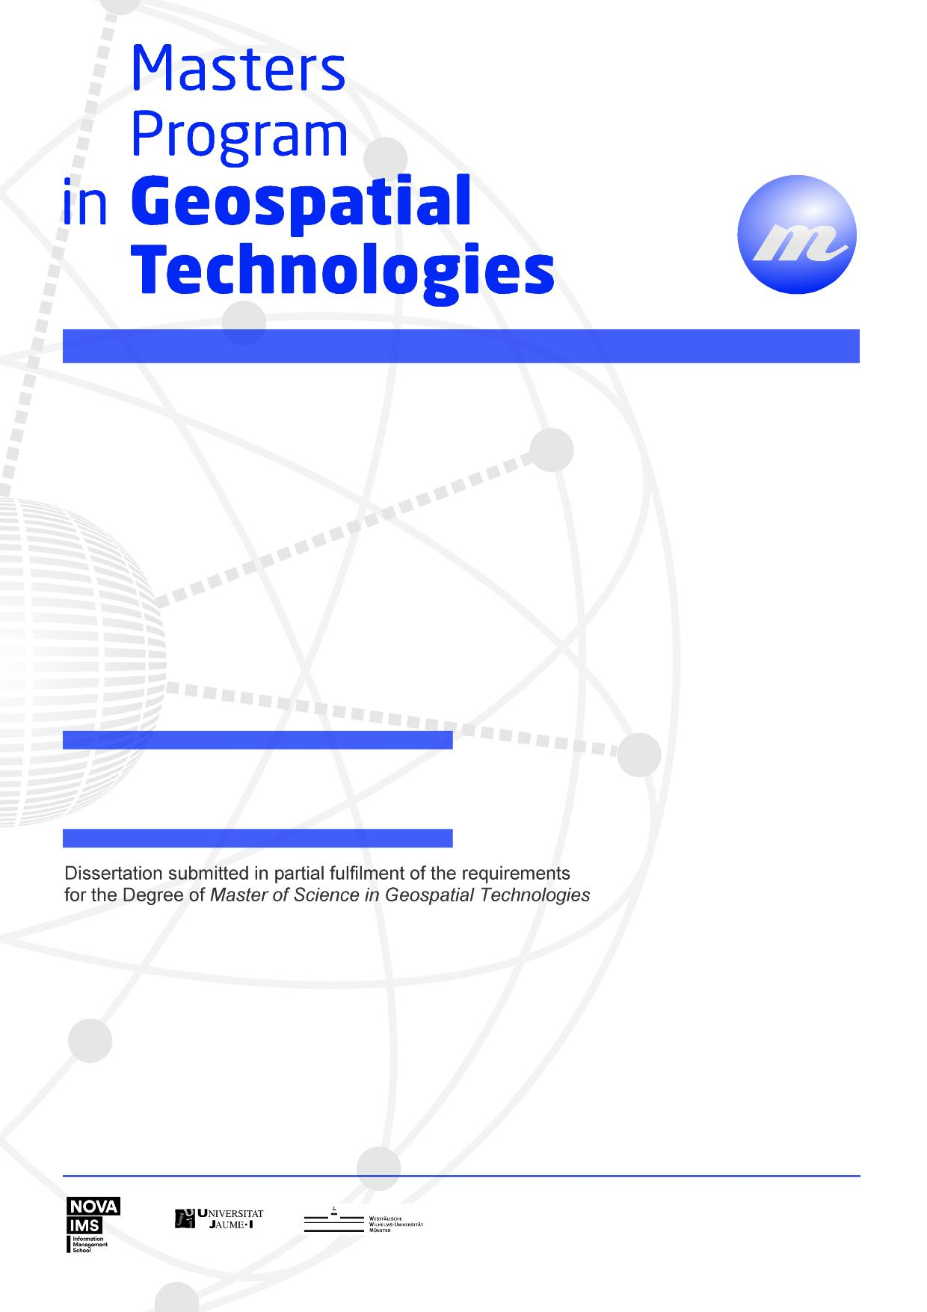

**Geovisualizing topics in texts**

**Transforming texts to maps:**

Mahesh Thapa

**Transforming Texts to Maps: Geovisualizing topics in texts**

Dissertation Supervised by

**Francisco Ramos, PhD**

Associate Professor

Department of Computer Languages and Systems

University Jaume I,

Castellón, Spain

Dissertation co-supervised by

**Oscar Belmonte Fernández, PhD**

Associate Professor

Department of Computer Languages and Systems

University Jaume I

Castellón, Spain

**Roberto Henriques, PhD**

Assistant Professor

NOVA Information Management School

University of New Lisbon

Lisbon, Portugal

February 2017

# ACKNOWLEDGMENTS

I would like to thank all those without whom this dissertation would not have been possible.

I would like to express my sincere gratitude to Dr. Francisco Ramos, Dr. Oscar Belmonte Fernández and Dr. Roberto Henriques for supervising the dissertation work.

I am grateful to the Erasmus Mundus program for the scholarship to purse the course M.Sc in Geospatial Technologies without which it would be a far-fetched dream.

Finally, I would like to take this opportunity to express my love and gratitude to my family who have been supportive to me in all the choices that I have made.

**Transforming Texts to Maps: Geovisualizing topics in texts**

# ABSTRACT

Unstructured textual data is one of the most dominant form of communication. Especially after the adoption of Web 2.0, there has been massive surge in rate of generation of unstructured textual data. While large amount of information is intuitively better for proper decision making, it also means that it becomes virtually impossible to manually process, discover and extract useful information from textual data. Several supervised and unsupervised techniques in text mining have been developed to classify, cluster and extract information from texts. While text data mining provides insight to the contents of the texts, these techniques do not provide insights to the location component of the texts. In simple terms, text data mining addresses “What is the text about?” but fails to answer the “Where is the text about?” Since textual data have a large amount of geographic content (estimates of about 80%), it can be safely reasoned that answering “Where is the text about?” adds significant insights about the texts. In this study, a collection of news articles from the year 2017 were analyzed using topic modelling, an unsupervised text mining technique. Topics were discovered from the text collections using Latent Dirichlet Allocation method, a popular topic modelling technique. Topics are probability distribution of words which correspond to one of the concepts covered in the text. Spatial locations were extracted from text documents by geoparsing them. Topics were geovisualized as interactive maps according to the probability of each spatial location word which contributed to the corresponding topic. This is analogous to thematic mapping in GIS. Coordinates obtained from geoparsed words provide basis for georeferencing the topics while the probability of such location words corresponding to the particular topics provide the attribute value for thematic mapping. An interactive geovisualization was constructed using leaflet library. A visual analysis of the maps were made to see if they provided spatial insight into the topics.

KEYWORDS

Topic Modelling

Geoparsing

Natural Language Processing

Geovisualization

Spatial Insight

# ACRONYMS

**API -** Application Programming Interface

**Kb** - Kilobytes

**NLP** - Natural Language Processing

**LDP -** Latent Dirichlet Allocation

**LSI –** Latent Semantic Indexing

Table of Contents

ACKNOWLEDGMENTS iii

ABSTRACT iv

KEYWORDS v

ACRONYMS vi

INDEX OF FIGURES ix

INDEX OF TABLES x

1. INTRODUCTION 1

1.1 Background 1

1.2 Aim and objective 2

2. Literature review 3

2.1 Text Mining 3

2.2 Topic Modeling 3

2.3 Natural Language Processing 4

2.4 Extracting Location Information from Text 4

2.5 Relevant works in text visualization 5

3. Methodology 6

3.1 Building Corpus from text collections 6

3.2 Extraction of Topic Model 8

3.3 Identification of location information from the collection of text 9

3.4 Geovisualization 9

4. Results 10

4.1 Overview 10

4.2 Topic Models 10

4.3 Geovisualization 11

5. CONCLUSIONS 13

6. FUTURE WORK 14

7. References 15

8. APPENDICES 16

# INDEX OF FIGURES

Figure 1: Overview of text mining methods (Source: *http://chdoig.github.io/acm-sigkdd-topic-modeling/#/*) 11

Figure 2 : Sample terms in topics(Source: (D. Blei et al., 2010)) 13

Figure 3: Intutitive digram for Topic Modeling using LDA (D. Blei et al., 2010) 15

Figure 4: LDA Plate Notation (D. M. Blei & Blei, 2008) 15

Figure 5: Methodology 23

Figure 6 : Visualization of topics (Topic 1 highlighted in red) using pyLDAvis 28

Figure 7: Visualization of topics (Topic 10 in red) using pyLDAvis 29

Figure 8: Screenshot of Geovisualization of Topic Number 0 29

Figure 9: Screenshot of Geovisualization of Topic 9 30

# INDEX OF TABLES

Table 1 : Text mining functions and methods 4

Table 2 : Common topic modelling methods 6

Table 3: Categories and number of news 14

# INTRODUCTION

## 1.1 Background

Out of many ways of expressing and storing information, textual format is by far the most dominating one. A query in google for number of books at the time of writing this document returns around 130 million. Besides books, textual information are also expressed in the form of newspapers, magazines, letters, etc. Even before the advent of internet technology, information in the form of text was already overwhelming. After the advent of internet technology, the generation and circulation of textual information has exploded. Besides the digitization of traditional form of textual information such as books into e-books, magazines into e-magazines and letters into emails, newer sources of textual information were devised such as web pages and blogs. A much bigger surge was seen in amount of textual information with the paradigm shift from Web 1.0 to Web 2.0. Web 2.0 allowed users not only the opportunity to view and consume the information but also create and post their own content (O'Reilly, 2012). After the adoption of Web 2.0, the dramatic rise in textual information came along with the rise of social networking sites such as Facebook and microblogging sites as Twitter.

With the advent of internet technology, there has been massive surge in textual information. While information definitely is the key to proper decision making, huge amount of information can actually be detrimental (Buchanan & Kock, 2001). First, larger amount of information demands larger amount of resources for processing it. Secondly, humans only have a limited consumption capacity regarding information. While it was considered that good decisions came from considering all the information, it is no longer a rational choice given the vast amount of information (Etzioni, 1989). The vast amount of information and limited capacity to comprehend it, stimulated the development of tools and techniques to discover new information from unstructured text. This process of discovering information from text have matured to a new field, which is now known as text mining or text data mining. Text data mining can also be considered as exploratory data analysis which is useful in discovering unknown information from the texts (Hearst, 1999).

While text data mining has been applied in several fields for exploratory data analysis from unstructured text, a combination of text mining with emphasis on location component will add an additional dimension for discovering information. The location component in unstructured data is quite strong as captured by the common phrase in geospatial sector, “80% of data have location component”. With such a strong component of unstructured text being geographic, there is little doubt that text mining with a geospatial focus would prove useful. It is not a question of will it be useful but how can it be made useful. One of the strong benefits that could possibly be exploited by considering the location component is that the discovered information can be located on a map. As expressed by Russian writer Ivan Turgeney, “The drawing shows me at one glance what might be spread over ten pages in a book.” A combination of text mining and geovisualization provides more insight into the unstructured text for discovering information from it.

## 1.2 Aims and objectives

The primary aim of this research is to discover hidden concepts in collections of texts and geovisualize these concepts which helps in providing spatial insight into the texts. Using topic modelling, one of the many techniques in text mining, a topic model is prepared from collections of texts. The topic model consists of number of topics which essentially represent the concepts in the texts. The contribution of location components that are present in the collection of the text are computed for each topic. These contributions are geovisualized using geovisualization libraries.

The objectives of the research are as follows:

1. Extract topic model from collection of unstructured texts
2. Compute the contribution of location components in the texts to each of the generated topics
3. Geovisualize the contribution of location components in each topic

# Theoretical review

## 2.1 Discovering and extracting information from unstructured texts: Text Mining

The massive rate of text data generation along with already existing text data is one of the biggest impetus to the rapid development in the field of text mining. Text data constitutes useful information in various form of books, newspaper, tweets, posts, blogs, etc. However, given the huge amount of text, manual extraction of information from texts is both costly as well as time-consuming. Also, humans have only so much capacity to consume information and can be overloaded with information leading to bad decision making (Buchanan & Kock, 2001). Hence, computer based automatic methods are advisable for extracting information from texts. However, information in texts based on natural language are in a form that it is anything but easy for machines to extract the hidden information (Hearst, 1999). Understanding and making sense of natural language is a trivial matter to humans but making machines do the same is a formidable challenge.

Text mining was first introduced in (Feldman et al., 1998) as the technique to extract non-trivial information from text data(Allahyari et al., 2017). Several text mining methods based on supervised and unsupervised machine learning methods have been developed. The figure below gives an overview of the major methods in text mining.

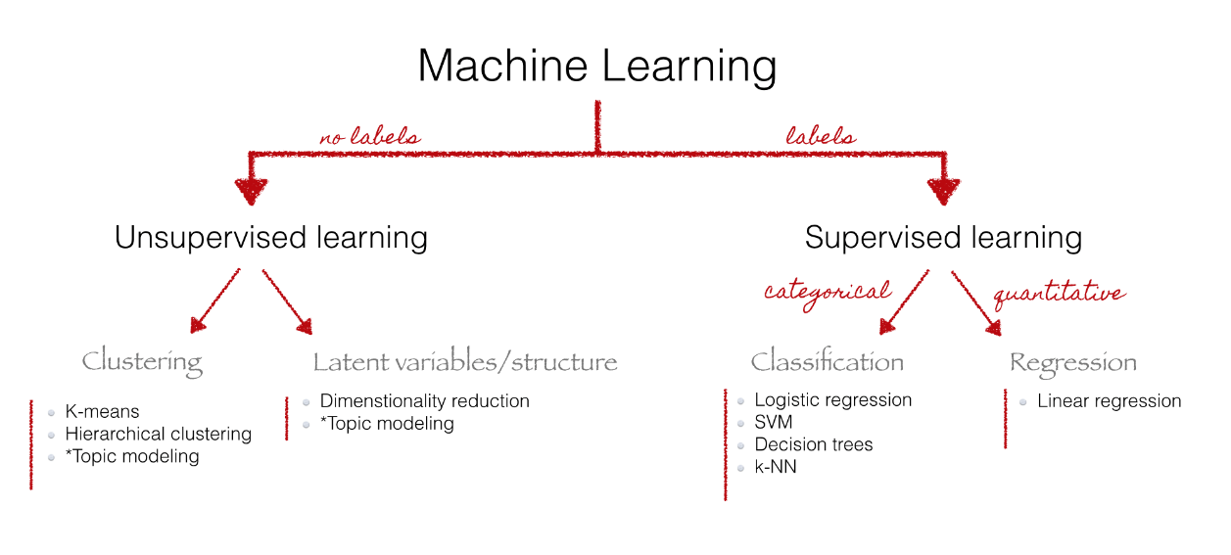

Figure 1: Overview of text mining methods (Source: *http://chdoig.github.io/acm-sigkdd-topic-modeling/#/*)

Supervised learning methods require labelled training data so as to learn from them and make predictions on the unseen data such as classifying documents into predefined categories. The major limitation in employing supervised learning is the availability of labelled training data that is specific to the purpose and domain of the work. Algorithms based on supervised learning that provide good results for a specific purpose and domain may not provide equally good results for other purposes or different domains. Unsupervised learning in text mining have edge over supervised learning as they do not require training samples. However, unsupervised learning method do not replace supervised learning as all text mining tasks cannot be done only by using unsupervised learning.

The supervised and unsupervised methods developed in text mining are oriented towards fulfilling the following major functions: text categorization; text clustering; concept mining; information retrieval and information extraction(Ghosh, Roy, & Bandyopadhyay, 2012). The major functions in text mining and the methods in accordance to (Allahyari et al., 2017) are presented in the table below.

Table 1 : Text mining functions and methods

|  |  |  |
| --- | --- | --- |
| **Sn.** | **Text mining function** | **Methods used** |
| 1 | Classification | 1. Naïve Bayes Classifier 2. Nearest Neighbor Classifier 3. Decision Tree Classifiers 4. Support Vector Machines |
| 2 | Clustering | 1. Hierarchical Clustering Algorithms 2. K-means Clustering 3. Probabilistic Clustering and Topic Models |
| 3 | Information Extraction | 1. Named Entity Recognition (NER) 2. Hidden Markov Models 3. Conditional Random Fields 4. Relation Extraction |

## 2.2 Discovering concepts in texts: Topics and Topic Modeling

In order to visualize a large collection of texts, it is of prime importance to know the different hidden concepts that the text contains without manually going through all of the texts. Clustering functions in text mining come very close to it. K-means clustering and Hierarchical clustering algorithms cluster the documents into different groups. However, there is no warranty that a single document contains only a single concept. This limitation is overcome by topic modelling. The outcome of topic modelling are a list of group of words that provide human with a sense of concept covered in the text. Each group of words is called a topic. The diagram presented below from the paper (D. Blei, Carin, & Dunson, 2010) gives a lucid idea of what a topic means in context of topic modelling.

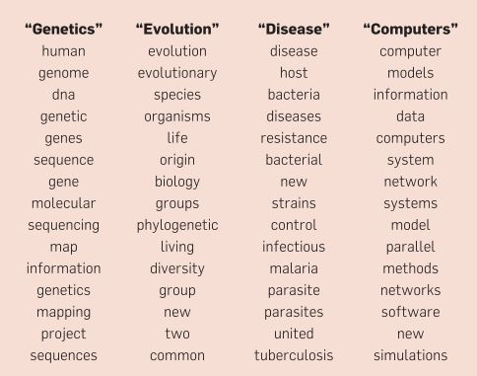

Figure 2 : Sample terms in topics(Source: (D. Blei et al., 2010))

The top 15 words in each of the four topics are displayed in the above figure. The list of words gives insight to the contents in the collection of texts to a human reader. It is clear from the figure above that the contents of the texts from which the topics were generated covered at least four concepts, namely genetics, evolution, disease and computers.

The premise of topic modelling is that a collection of text document contains various hidden topics. And each document contains one or more topics at varying proportions(Zhao et al., 2015). Several methods have been proposed and developed for topic modelling. Some of the common methods used for topic modelling are listed in the table below.

Table 2 : Common topic modelling methods

|  |  |
| --- | --- |
| **Sn.** | **Topic Modelling Method** |
| 1 | Latent Semantic Analysis (LSA) |
| 2 | Probabilistic Latent Semantic Analysis (PLSA) |
| 3 | Latent Dirichlet Allocation (LDA) |
| 4 | Correlated Topic Model (CTM) |

Each of the topic modelling have their own methods, strengths and weaknesses going through each of which is beyond the scope of this study. There are several papers which discuss about these such as (Sharma & Sharma, 2017), (Alghamdi & Alfalqi, 2015)

In this study, Latent Dirichlet Allocation (LDA) was implemented for topic modelling LDA is improvement over LSA and it provides probabilistic topics which are interpretable rather than a semantic space. The probabilistic topics are key to geovisualization as the probabilities are treated as attribute values. Also, LDA could be modelled as finite number of topics which meant there would be finite number of visualizations. Given the rational above LDA was the optimal choice for topic modelling with respect to the needs of this study. LDA is discussed in further details in the section below.

### 2.2.1 Latent Dirichlet Allocation (LDA)

LDA is the most common method of topic modelling(Zhao et al., 2015). There are several variations of LDA that it has actually acted as the impetus for development of other topic models(D. M. Blei & Lafferty, 2009). LDA is a generative probabilistic method for discovering topics in which each document in a collection is modelled as a finite mixture of topics(D. M. Blei et al., 2003). The assumption of LDA that each document contains more than one topic is very rational as each document tends to be heterogeneous in nature covering many concepts. This is shown in the figure below which was included in the paper (D. Blei et al., 2010).

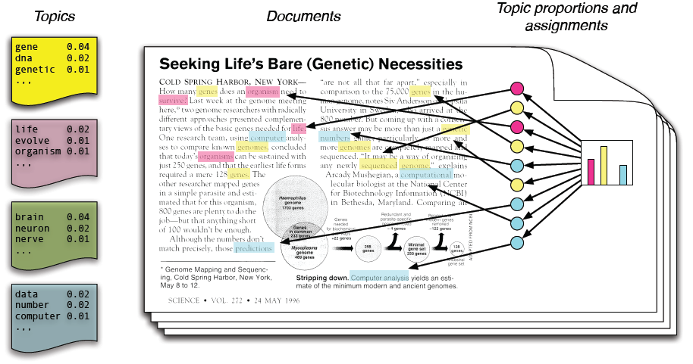

Figure 3: Intutitive digram for Topic Modeling using LDA (D. Blei et al., 2010)

Although the figure above shows a single document, it is modelled as constituting of finite number of topics. The document is modelled into four topics as shown in the left side of the figure above. In a document, the topics have various proportions depending upon the content of the document.

The plate notation of LDA is shown in figure below.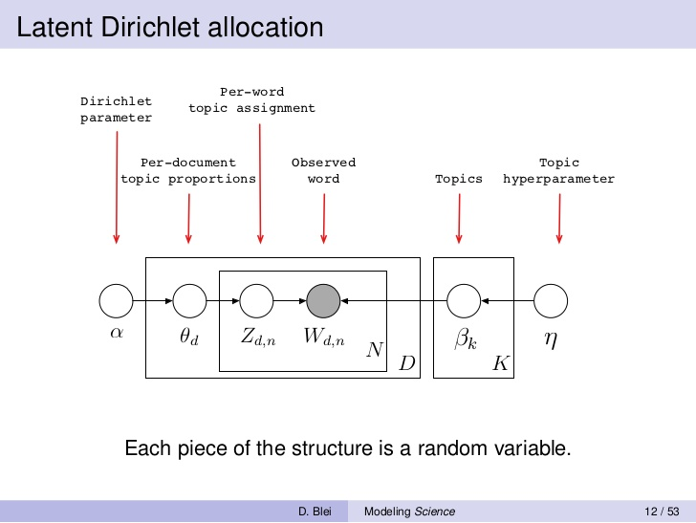

Figure 4: LDA Plate Notation (D. M. Blei & Blei, 2008)

### 2.2.2 Software Implementations for Topic Modelling

There exists a large number of tools that can perform topic modelling, particularly LDA. These are listed in the table below.

|  |  |  |
| --- | --- | --- |
| Sn. | Tool name | Implementation language |
| 1 | Mallet | Java , Wrapper in R |
| 2 | Topic Models (Package) | R |
| 3 | LDA (Package) | R |
| 4 | Gensim | Python |
| 5 | LDA-C | C |
| 6 | GibbsLDA++ | C and C++ |
| 7 | Stanford Topic Modeling Toolbox | Java |

In this study, we selected Gensim as our choice for implementing topic modelling. Gensim is open source python library for topic modelling. It has large user and developers’ community. It supports topic modelling, document indexing and similarity retrieval. Gensim has implementations of Latent Semantic Analysis (LSA), Latent Dirichlet Allocation (LDA) and Hierarchical Dirichlet Process (HDP). The Genism package implements a variation of LDA based upon the paper Online Learning for Latent Dirichlet Allocation (Hoffman, Blei, & Bach, 2010) which allows for handling of large amount of document collection including data that arrives in stream. The choice for Gensim in this study was due to the memory efficiency of the package. The package uses generators and iterators which are part of the Python for streamed data processing. The streamed data processing allows processing of large amount of text data even with lower processing capabilities.

## 2.3 Natural Language Processing (NLP)

Natural Language Processing (NLP) is a computerized approach to analyze the texts. Some of the most common tasks in natural language processing are word tokenization, sentence tokenization, part of speech tagging, named entity recognition, dependency parsing, coreference resolution, etc. NLP provides tools and techniques for text mining as well as topic modelling. In this study, NLP is used for preprocessing the textual data before they are feed into topic modelling algorithms.

A list of common NLP open source software are presented in the table below:

|  |  |  |
| --- | --- | --- |
| Sn. | Software/Tool/Package | Implementation Language |
| 1 | Natural Language Toolkit | Python |
| 2 | Spacy | Python |
| 3 | Stanford Core NLP | Java, Python Wrappers |
| 4 | Apache OpenNLP | Java |

In this study, Spacy was selected as NLP tool which defines itself as an industrial strength NLP. It is open source and has a large user and developer’s community. It comes with pre-trained statistical models and supports multiple languages. One of the reason for selecting Spacy was that it is implemented in Python which made integrating it to topic modelling much easier.

## 2.4 Extracting Location Information from Text

While topics extracted using topic modelling provides theme for visualization, location information from texts are essential for georeferencing the topics for geovisualization. While it is a mundane task for humans, automatic location extraction is a challenging field with a large amount of research work. One of the very active research and development field in this field is Named Entity Recognition (NER). NER identifies words that denote person, organization, location, object, etc. Different NER implementations have different classes of entities(Atdaǧ & Labatut, 2013).While NER identifies several classes of entities, only entities having location information are of interest for the purpose of georeferencing the topics. Almost all popular natural language processing software have facility for recognizing named entities. While named entity recognizes the names entities with locations, it is also necessary to extract the geographic location name of the entity. Digital gazetteers are specifically constructed to have unambiguous location information. Digital gazetteers contain structured information about geographic location. Digital gazetteers are particularly useful for automated and unambiguous georeferencing of location information in a text which is called geoparsing(Goodchild & Hill, 2008). Some of the popular geoparsing tools and services are listed in the table below:

|  |  |  |
| --- | --- | --- |
| Sn | Software/Tool/Service | Implementation |
| 1 | Clavin | Java |
| 2 | Mordecai | Python |
| 3 | Geoparse.io RESTful web API | Python API |

In this study, Geoparse.io is used for geoparsing the texts. It is a RESTful web API that returns the information about the locations on the request text as GeoJSON. The Geoparse.io web API uses GeoNames geographical database as digital gazetteer. Although it is not free, it allows 1000 API calls for free per month. Geoparse.io was selected for this study as it had small learning curve and had API in python.

## 2.5 Relevant works in text visualization

There are

All of these visualization techniques intend to answer “What “is in the text but fail to answer the “Where” portion of the text. There is a compelling motivation for development of text visualization technique that combines both the textual and spatial components of text data and can answer both “what” is in the text as well as “where” component of the text.

In this study, a new technique is demonstrated that visualizes large collection of texts by extracting the concepts (topics) covered in the collection and individually mapping the topics based upon the influence of spatial location on each topic.

# Relevant Works

## 3.1 Relevant works in text mining from newspaper articles

There have been several domain specific studies that have utilized topic modelling to discover concepts from collection of texts as topics. Text mining from newspaper is one of the most research active area. Newspaper are the source of unedited and unmodified version of history which arouses interest to researchers who want to get insight to the history(Cheney, 2013). The digitization of historical newspapers by libraries has also opened the opportunity for research in this field. The availability of such a data that spans decades if not centuries provides opportunities to study the changes in human history. (Torget, Mihalcea, Christensen, & Mcghee, 2010) used sample of around 230,000 pages of historical newspapers analysing the quantity and quality of the digitized content along with measurement of language pattern. (Godbole & Srinivasaiah, 2007) analysed sentiment from news and blogs. (Akhter, 2015) extracted information related to road accidents and visualized them interactively.

## 3.2 Relevant works in topic modelling

Studies that have considered both topic modelling and location component have primarily intended to improve topic modelling by segregating the texts based upon the location. (Hu & Ester, 2013) used locations of posts on social media to model user profiles using topic modelling and spatial location for improving location recommendation. (Pölitz, 2015) used spatial locations in newspapers and social media for explore topics in those regions. (Yin, Cao, Han, Zhai, & Huang, 2011) also used documents which were embedded with GPS coordinates for topic modelling to find topics that are coherent in a particular geographic region.

## 3.3 Relevant works in visualizing texts

A large number of studies exists in text visualizations. Also hundreds of text visualization techniques have been developed. (Cao & Cui, 2016) reviewed more than 200 papers based on text visualization techniques accumulated in Text Visualization Browser (*http://textvis.lnu.se/).* The paper identified five categories of text visualizations which are listed below.

1. Visualization of document similarity.
2. Visualization for revealing content of the document
3. Visualization of sentiments and emotions in the text
4. Visualization of the corpus
5. Visualization of domain-specific rich-text corpus

These techniques cover large and wide sectors of visualizing texts. However, even among such a large number of visualization techniques, texts are not visualized with focus on the location. The emphasis is on visualizing “What is the text about?” The component of “Where is the text about?” remains unanswered.

# Data

In this section, a brief summary of the news data used in this study is provided. An overview of the collection and filtering process is also discussed.

News from different online news sources were downloaded that belonged to the year 2017. All of the news were downloaded based upon the following seven keywords (category) in google. The keywords and the number of news articles are presented in the table below.

Table 3: Categories and number of news

|  |  |  |  |
| --- | --- | --- | --- |
| **Sn.** | **Keyword (Category)** | **No. of articles** | **Visual representation of number of articles** |
| 1 | World Cup | 60 |  |
| 2 | Wildlife Poaching | 35 |
| 3 | Tornado | 84 |
| 4 | Nuclear War | 46 |
| 5 | Election | 98 |
| 6 | Ebola | 91 |
| 7 | Deforestation | 98 |
|  | **Total** | **512** |

The articles were downloaded by automatizing the process by writing scripts in python. The scripts are included in the appendix section. Newspaper3k python package was used for downloading the articles. The package can be accessed on GitHub at *https://github.com/codelucas/newspaper*. The articles were sampled to check if they had any anomaly. Significant number of files less than 3Kb contained artefacts or were empty. These articles were filtered. Also, files larger than 8Kb were filtered as geoparsing API header had limitation of 8Kb in size. The above table shows the numbers of articles that persisted after filtered. Samples of the downloaded news articles are included in the appendix. It is to be noted that although the news articles are downloaded based on several categories, these are feed into topic modelling algorithms without any annotations. The categories are used only for analyzing the topics extracted using topic modelling algorithms and also qualitatively analyzing the geovisualizations.

# Methodology

This section elaborates on the process that initiates from collection of the online news articles to geovisualization of the articles in the form of interactive maps. The theoretical background of the methodologies applied here are discussed in chapter 2: theoretical review.

## 5.1 Building Corpus of News Articles

This procedure of collection and filtration of news articles is explained in Chapter 4: Data. Once done through this process, we already have a corpus suitable for our study. In our study, we perform topic modelling using Latent Dirichlet Allocation (LDA) algorithm which is an unsupervised learning algorithm. Hence, the news articles are not annotated based upon their category. The necessity of building our own corpus is well expressed in (Xiao, 2010) which states that although there exits thousands of corpus, these are created for certain research purposes and most are not available publicly. It is one of the most time consuming and costly process in text mining.

## 5.2 Building Corpus from News Articles

In this study, different type of collections of texts are considered for visualization. One of them is the collection of news articles related to earthquake in Nepal. These articles were collected manually from different news sources. Corpus is generally understood as a large collection of text documents. However a corpus can have other accompanying information. Such as annotations of named entities, part of speech, etc. While there exists thousands of corpus, these are created for certain research purposes and most are not available publicly. The specific purpose of corpus creation means that although it is time consuming, specific research purpose demands creation of own corpus. In this study, news articles relevant to various fields are chosen to build corpus.

In this study, Gensim is used for corpus building. Gensim stands out among natural language processing software as it focuses particularly on topic modelling. It is implemented as a Python library. The strength of Gensim is that it can process large amount of text data even with limited computing power. The algorithms implemented in Gensim are memory independent. The source code of Gensim is hosted in GitHub and can be accessed at [*https://github.com/RaRe-Technologies/gensim*](https://github.com/RaRe-Technologies/gensim).

Turning text to corpus involves steps which are subject to the purpose of the library. However, the common task is to covert the text into machine readable form such that it is simpler and facilitates faster computation. Computation of texts in its native format is slow for computers. Hence, texts are converted into vectors for faster computation. There are several methods in which texts can be converted to vectors. Some of the methods consider the grammar and the word order while other methods only consider the frequency of words. Again, the choice of method depends upon the purpose of the study. In this study, bag-of-words (BOW) is implemented for converting texts into vectors. The bag-of-words method disregards the grammar as well as the order of the words. It only considers the frequency of words in the text collection. According to this method, every word in a collection of text is given a unique integer id and the number of appearances of the word in the collection is counted. It is a common method implemented in topic modelling and is also implemented in this study.

Before converting words to vectors, the text must be preprocessed. The importance of preprocessing cannot be emphasized more as it is what prevents an input being a garbage. For preprocessing, several natural language processing tools are required. In this study, Spacy is used for this purpose. Spacy is free and open source library for natural language processing. It is also implemented in Python. The source code of Spacy is also open in GitHub and can be accessed at [*https://github.com/explosion/spaCy*](https://github.com/explosion/spaCy). The choices of preprocessing steps again depend upon the purpose of the study. Preprocessing steps that are best fit for a purpose could produce garbage for other purposes. The following preprocessing steps were implemented in this study:-

1. Text Lemmatization

Lemmatization converts the words into its canonical or citation form(Bird, Klein, & Loper, 2009). Example: The lemmatization of swims and swam is swim.

1. Removal of stop-words

Stop-words are such words in a text which do not add any value to the purpose of the study. Again, this depends upon the purpose of the study. Each natural language processing software come with their own set of stop-words. Although, there is some overlap between them, there is no consensus in a universal set of stop-words. Many a times, defining stop-words is an iterative process. The results are examined and the words that add no meaning to the results are added to the list of stop-words.

1. Remove numbers, punctuation marks, symbols

Numbers, punctuation marks and symbols are removed from the text as these do not add any value to the topics.

1. Detect bigrams and trigrams

A combination of words such as climate change, tectonic plate, car race, ministry of education, etc., provide different meaning in combination than the individual words. These words, if treated as separate words, would provide different insight than what is intended in the texts. These words are called n-grams. Bigrams are combination of two words and trigrams are combination of three words. N-gram identification is especially important because the study has implemented bag-of-words model for transforming words to vectors as bag-of-words model do not preserve the order of the words. Bigrams and trigrams are highly prevalent in names of locations such as Pacific Ocean, Suez Canal, Kathmandu Valley, Grao de Castellon, etc. As these locations are to be mapped, bigrams and trigrams are identified in the texts and are processed as single entity. In this study, only bigrams and trigrams were considered. However, depending upon the language and the contents in the collection of texts, it is necessary to implement higher level of n-grams.

Once the process of preprocessing is complete, the text is converted to vectors based upon bag-of-words model and a corpus is built. In terms of Gensim, a corpus is a list of lists. The larger list represents the entire collection of texts. Each of the smaller lists represent individual document.

## 5.3 Extraction of Topic Model

Topic models are generated once the corpus are built. In this study, the topic model is generated using Latent Dirichlet Allocation (LDA) which is a generative probabilistic method of topic modelling. The basic assumption of LDA is that each document is a mixture of topics. And each topic is a probability distribution over words. The figure below conspicuously demonstrates the assumptions in LDA.

The only model parameter for LDA in its implementation in Gensim is the number of topics to be generated. As of now, there is no straight forward and agreed upon method for specifying the number of topics. However, there are several measures of evaluating the topic models such as perplexity, topic coherence, human interpretability, etc. A python library, pyLDAvis is available for visualizing the topics. It can be accessed at [*https://github.com/bmabey/pyLDAvis*](https://github.com/bmabey/pyLDAvis)*.*

## 3.3 Identification of location information from the collection of text

The location information is critical in Geovisualizing the topics as it is used to georeferenced the topics. The location information is extracted by geoparsing the texts. In this study, Geoparser.io is used for geoparsing the texts. Geoparser.io is implemented as a RESTful web API. It is not free but provides 1000 free API calls per month. The response of the API call is in GeoJSON format. The response has the following information of interest: name of the location, country, state/province level administrative division, geographic feature type and coordinate.

## 3.4 Geovisualization

The mapping of topics is analogous to mapping of a thematic layer in cartography. The thematic layer is mapped according to its location. Then, it is symbolized according to one of its attribute value. In cases of continuous data, the attribute data is interpolated for visualization. For example a temperature map is visualized based upon finite number of measurements at various locations which are then interpolated. Similar approach is followed in mapping the topics generated from topic modelling. For this locations are the coordinates obtained by geoparsing all the text collection that were used for generating the topic model. To map a topic, say Topic A, the probability of the location name lying in Topic A was extracted from the topic. This probability is the attribute value of the location which is interpolated to geovisualize the topic. The geovisualization was done using leaflet geovisualization library which is implemented in JavaScript. The geovisualization was done as heatmaps.

# Results and Discussion

## 4.1 Overview

Topic models which essentially represent the hidden concepts in the collection of texts were generated using topic modelling in Gensim. The spatial locations in the texts were extracted using geoparsing. The probability of the spatial location lying in each topics were extracted. Using these probability as the attribute value, heatmaps were generated as geovisualization of the topics.

## 4.2 Topic Models

For the text collection of news related to earthquake in Nepal, topic model was generated using LDA in Gensim. The topic model is presented in the Appendix. A visualization of one of the topic generated using pyLDAvis is shown in the figure below.

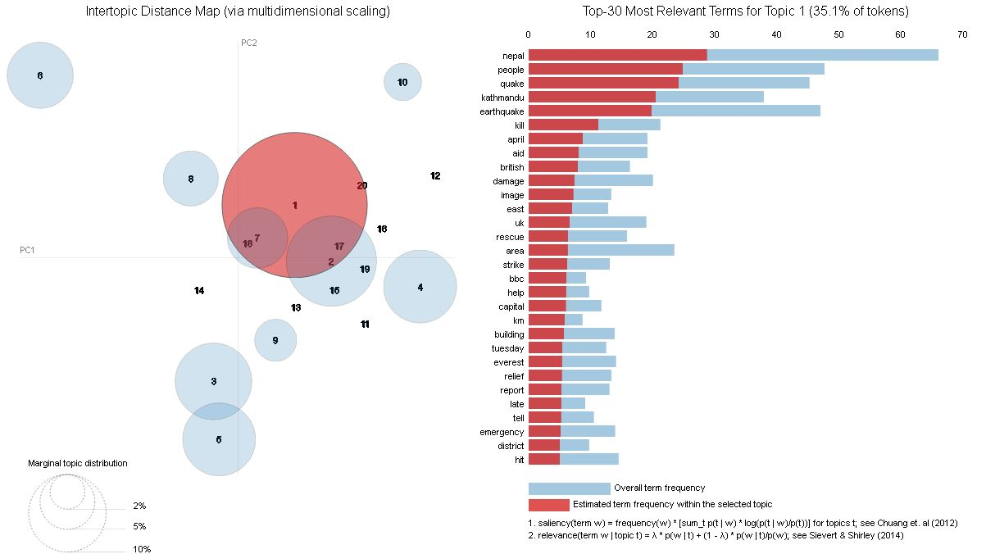

Figure 6 : Visualization of topics (Topic 1 highlighted in red) using pyLDAvis

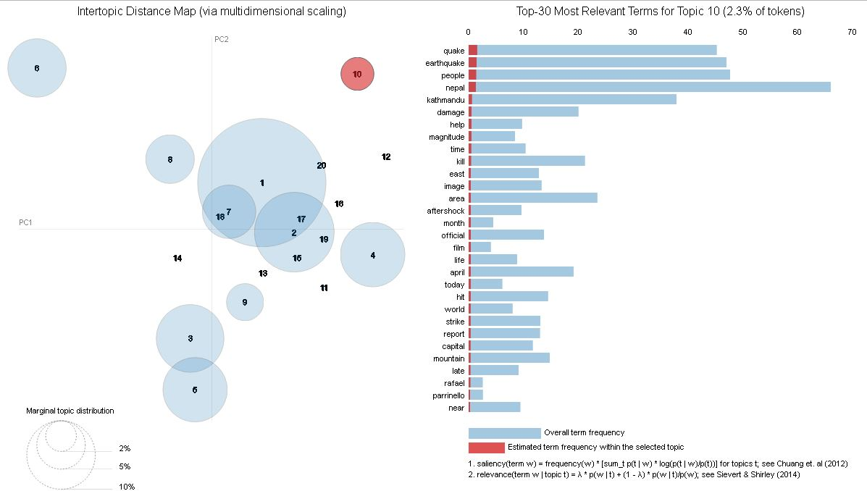

Figure 7: Visualization of topics (Topic 10 in red) using pyLDAvis

## 4.3 Geovisualization

The topics are geovisualized as heatmaps using leaflet geovisualization library. Screenshots of the geovisualization are shown below.

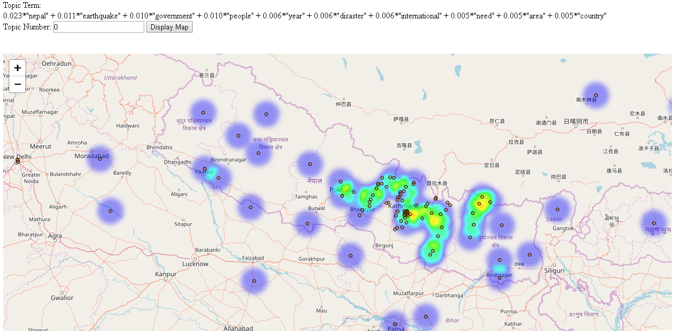

Figure 8: Screenshot of Geovisualization of Topic Number 0

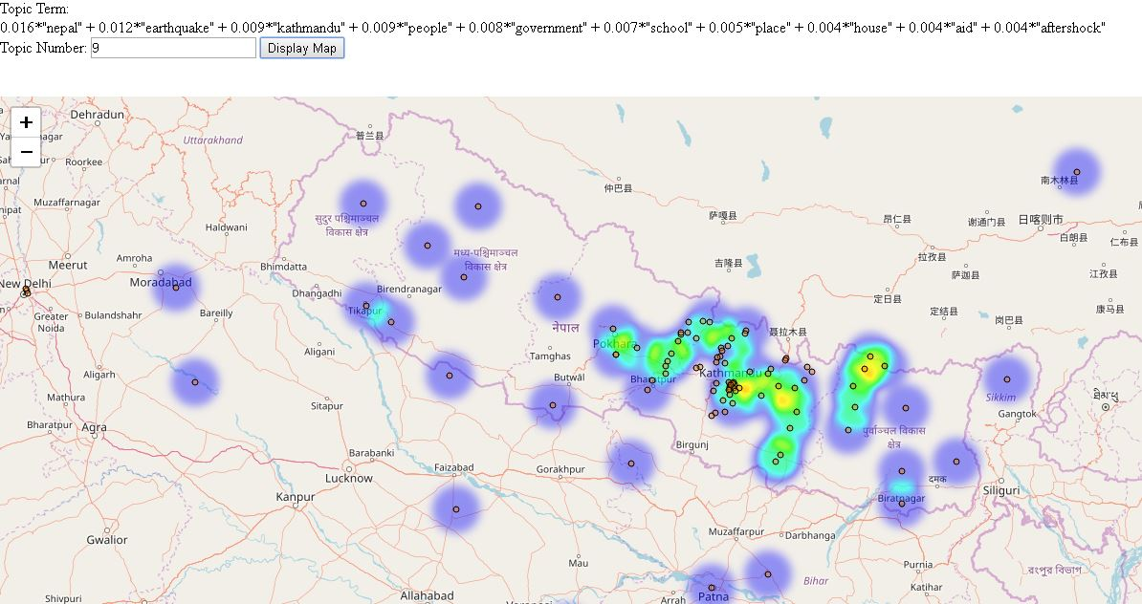

Figure 9: Screenshot of Geovisualization of Topic 9

# CONCLUSIONS

Topic models are useful in discovering topics from a large collection of texts. These topic models provide insights into the contents of the texts. However, they do not provide spatial insight into the texts. Since, textual data have a large spatial component, geovisualization of the topics have potential in providing insights of the text collection. In this study, topics extracted from topic models are successfully geovisualized based upon the probability of the location names lying in each subject.

# FUTURE WORK

# References

Akhter, H. (2015). Information Extraction and Interactive Visualization of Road Accident Related News, *128*(5), 37–40.

Alghamdi, R., & Alfalqi, K. (2015). A Survey of Topic Modeling in Text Mining. *International Journal of Advanced Computer Science and Applications*, *6*(1), 147–153. https://doi.org/10.14569/IJACSA.2015.060121

Allahyari, M., Pouriyeh, S., Assefi, M., Safaei, S., Trippe, E. D., Gutierrez, J. B., & Kochut, K. (2017). A Brief Survey of Text Mining: Classification, Clustering and Extraction Techniques. Retrieved from http://arxiv.org/abs/1707.02919

Atdaǧ, S., & Labatut, V. (2013). A comparison of named entity recognition tools applied to biographical texts. *2013 2nd International Conference on Systems and Computer Science, ICSCS 2013*, 228–233. https://doi.org/10.1109/IcConSCS.2013.6632052

Bird, S., Klein, E., & Loper, E. (2009). *Natural Language Processing with Python*. *Text* (Vol. 43). https://doi.org/10.1097/00004770-200204000-00018

Blei, D., Carin, L., & Dunson, D. (2010). Probabilistic topic models. *IEEE Signal Processing Magazine*, *27*(6), 55–65. https://doi.org/10.1109/MSP.2010.938079

Blei, D. M., Edu, B. B., Ng, A. Y., Edu, A. S., Jordan, M. I., & Edu, J. B. (2003). Latent Dirichlet Allocation. *Journal of Machine Learning Research*, *3*, 993–1022. https://doi.org/10.1162/jmlr.2003.3.4-5.993

Blei, D. M., & Lafferty, J. D. (2009). Topic Models. *Text Mining: Classification, Clustering, and Applications*, 71–89. https://doi.org/10.1145/1143844.1143859

Buchanan, J., & Kock, N. (2001). Information Overload: A Decision Making Perspective (pp. 49–58). Springer, Berlin, Heidelberg. https://doi.org/10.1007/978-3-642-56680-6_4

Cao, N., & Cui, W. (2016). *Introduction to Text Visualization*. https://doi.org/10.2991/978-94-6239-186-4

Cheney, D. (2013). Text mining newspapers and news content : new trends and research methodologies Abstract :, 1–5.

Feldman, R., Fresko, M., Hirsh, H., Aumann, Y., Liphstat, O., Schler, Y., & Rajman, M. (1998). Knowledge Management: A Text Mining Approach. *Proc of the 2nd Int Conf on Practical Aspects of Knowledge Management（PAKM98*, *Basel*, *Swi*(April 2016), 1–10. Retrieved from http://citeseerx.ist.psu.edu/viewdoc/download?doi=10.1.1.93.7128&amp;rep=rep1&amp;type=pdf

Ghosh, S., Roy, S., & Bandyopadhyay, P. S. K. (2012). A tutorial review on Text Mining Algorithms, *1*(4), 223–233.

Godbole, N., & Srinivasaiah, M. (2007). Large-scale sentiment analysis for news and blogs. *Conference on Weblogs and Social Media (ICWSM 2007)*, 219–222. https://doi.org/10.1177/01461079070370040501

Goodchild, M. F., & Hill, L. L. (2008). Introduction to digital gazetteer research. *International Journal of Geographical Information Science*, *22*(10), 1039–1044. https://doi.org/10.1080/13658810701850497

Hearst, M. A. (1999). Untangling text data mining. In *Proceedings of the 37th annual meeting of the Association for Computational Linguistics on Computational Linguistics -* (pp. 3–10). https://doi.org/10.3115/1034678.1034679

Hoffman, M. ~D., Blei, D. ~M., & Bach, F. (2010). Online learning for latent dirichlet allocation. *Advances in Neural Information Processing Systems 23*, *23*, 856–864.

Hu, B., & Ester, M. (2013). Spatial topic modeling in online social media for location recommendation. *Proceedings of the 7th ACM Conference on Recommender Systems - RecSys ’13*, 25–32. https://doi.org/10.1145/2507157.2507174

Pölitz, C. (2015). Modelling Time and Location in Topic Models. In *Proceedings of the 2Nd International Conference on Mining Urban Data - Volume 1392* (pp. 95–96). Aachen, Germany, Germany: CEUR-WS.org. Retrieved from http://dl.acm.org/citation.cfm?id=3045776.3045791

Sharma, H., & Sharma, A. K. (2017). Study and Analysis of Topic Modelling Methods and Tools – A Survey. *American Journal of Mathematical and Computer Modelling*, *2*(2), 84–87. https://doi.org/10.11648/j.ajmcm.20170202.15

Torget, A. J., Mihalcea, R., Christensen, J., & Mcghee, G. (2010). Mapping Texts: Combining Text-Mining and Geo-Visualization To Unlock The Research Potential of Historical Newspapers. A White Paper for the National Endowment for the Humanities, 53. Retrieved from http://digital.library.unt.edu/ark:/67531/metadc83797/

Xiao, R. (2010). 7 - Corpus Creation. *The Handbook of Natural Language Processing*, 147–165. https://doi.org/doi:10.1201/9781420085938-c7

Yin, Z., Cao, L., Han, J., Zhai, C., & Huang, T. (2011). Geographical topic discovery and comparison. *Proceedings of the 20th International Conference on World Wide Web - WWW ’11*, 247. https://doi.org/10.1145/1963405.1963443

Zhao, W., Chen, J. J., Perkins, R., Liu, Z., Ge, W., Ding, Y., & Zou, W. (2015). A heuristic approach to determine an appropriate number of topics in topic modeling. *BMC Bioinformatics*, *16*(13), S8. https://doi.org/10.1186/1471-2105-16-S13-S8

# APPENDICES